The Hong Kong Polytechnic University

Department of Electronic and Information Engineering

EIE3331 Communication Fundamentals

**Mini-project**

**Report**

Name: YANG Tianyu

Student ID: 13102841D

Date: 2016/4/13

**Contents**

1. Steps 3

2. Diagram with unit & label 3

3. Procedure 5

4. Description 6

5. Source code comment 6

6. Brief explanation & way to run it 8

## Steps

Firstly establish the symbols for “00’, “01”, “10”, “11”, and then define the function for each label. Next input the data input to the system and do some QPSK or OQPSK transmissions for them. Finally get the output diagram.

## Diagram with unit & label

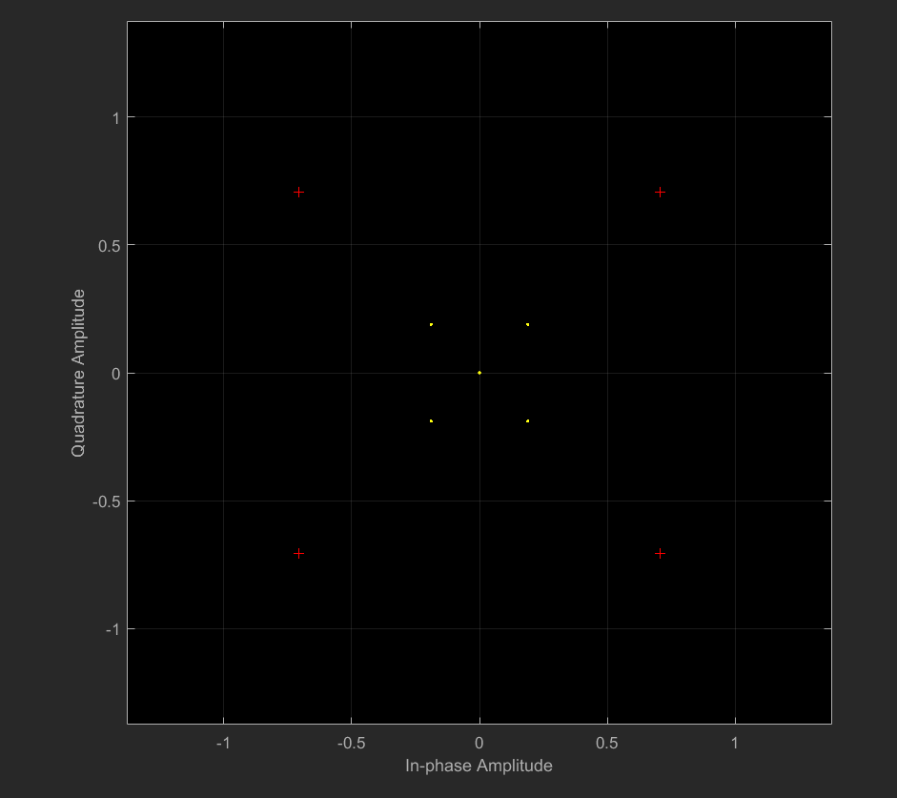

Constellation diagram of QPSK



Input value of 00,01,10,11



The QPSK waveform



The OQPSK waveform

## Procedure

Question 1:

Firstly establish a QPSK modulator and use the diagram to show the constellation diagram of QPSK. Set the input value of 00,01,10,11 and use MATLAB to plot the input waveform of each symbol. Show in Figure 1.

Question2:

For QPSK waveform, use an ‘if’ function to realize the loop of represent the input data to QPSK modulation and encode the symbol. Then plot the waveform in the diagram. Show in Figure 2.

Question3:

For OQPSK waveform, use an ‘if’ function to realize the loop of represent the input data to QPSK modulation and encode the symbol. Especially, the OQPSK need to move half of the time interval. Then plot the waveform in the diagram. Show in Figure 3.

## Description

To solve this question, I use MATLAB as programming tool. Definite symbols to represent 00,01,10,11 and modulate the input data by using QPSK and OQPSK modulation. Then plot the waveform on the screen.

## Source code comment

hMod = comm.QPSKModulator;

Rup = 16; % upsampling rate

hRCTxFilter = comm.RaisedCosineTransmitFilter(...

'Shape','Normal', ...

'RolloffFactor',0.5, ...

'FilterSpanInSymbols',Rup, ...

'OutputSamplesPerSymbol',Rup);

data = randi([0 3],100,1);

modData = step(hMod,data);

hScope = comm.ConstellationDiagram('SamplesPerSymbol',Rup);

txSig = step(hRCTxFilter,modData);

step(hScope,txSig) %Draw the constellation diagram of QPSK

tb=0:0.01:1;

bits=[1 0 1 1 0 0 1 0 0 1 1 0 0 0 1 1];

A=(2)^0.5;

Tc=1;

fc=1/Tc;%set sampling frequency

wc=2*pi*fc;

sym1=A*sin(wc*2*tb);%represent 00

sym2=A*sin(wc*2*tb+pi/2);%represent 01

sym3=A*sin(wc*2*tb+pi);%represent 10

sym4=A*sin(wc*2*tb+3*pi/2);%represent 11

figure(1)

subplot(2,2,1),plot(sym1)

set(title('00'));

subplot(2,2,2),plot(sym2)

set(title('01'));

subplot(2,2,3),plot(sym3)

set(title('10'));

subplot(2,2,4),plot(sym4)

set(title('11')); %Show theinput value of 00,01,10,11

mod=[];%For QPSK modulation steps

for i=1:2:16;

if(bits(i)==0 && bits(i+1)==0) mod=[mod sym1];

elseif(bits(i)==0 && bits(i+1)==1) mod=[mod sym2];

elseif(bits(i)==1 && bits(i+1)==0) mod=[mod sym3];

elseif(bits(i)==1 && bits(i+1)==1) mod=[mod sym4];

end

end

figure(2)

plot(mod)

set(gca,'XTick',[100,200,300,400,500,600,700,800])

set(gca,'XTickLabel',{'2T','4T','6T','8T','10T','12T','14T','16T'})

ylabel('s(t)')

sym5=A*sin(wc*2*tb+7*pi/4);%represent 00

sym6=A*sin(wc*2*tb+3*pi/4);%represent 01

sym7=A*sin(wc*2*tb+5*pi/4);%represent 10

sym8=A*sin(wc*2*tb+pi/4);%represent 11

mod1=[];%For OQPSK modulation steps

for i=1:15;

if(bits(i)==0 && bits(i+1)==0) mod1=[mod1 sym5];

elseif(bits(i)==0 && bits(i+1)==1) mod1=[mod1 sym6];

elseif(bits(i)==1 && bits(i+1)==0) mod1=[mod1 sym7];

elseif(bits(i)==1 && bits(i+1)==1) mod1=[mod1 sym8];

end

end

figure(3)

plot(mod1)

set(gca,'XTick',[200,400,600,800,1000,1200,1400,1500,1600])

set(gca,'XTickLabel',{'2T','4T','6T','8T','10T','12T','14T','15T','16T'})

ylabel('s(t)')

## Brief explanation & way to run it

Download the m files and open it in MATLAB. (Or input the source code to MATLAB m file) and press “run” buttonto run the program. Then you will get the diagram for constellation diagram, QPSK waveforms and OPSK waveforms.